**Forecasting of Singapore Direct Import and Direct Exports**

**with Time Series ARIMA and SARIMAX**

**Yek Yi Wei  
*School of Computing   
Singapore Polytechnic*  
Singapore**[***yekluke@gmail.com***](mailto:yekluke@gmail.com)

***(p2107631)***

**Abstract**

Based on the data set downloaded from the website by Department of Statistics Singapore for month 2000-01-01 to 2021-11-01, time series models ARIMA and SARIMAX were used in forecasting the Direct Import and Direct Export of Singapore. The two models were compared in their model fitting and prediction based on some common evaluation criteria such as MSE, RMSE, MAPE and R2 . Results indicated that SARIMAX model has better performance in forecasting the Singapore Direct Import and Direct Export. Therefore, SARIMAX model is applied to forecast the Direct Import and Direct Export from month after 2021-12-01. It is hoped that this study will provide insights to the policy makers or related parties to plan for future trade balance in Singapore.

Keywords—Direct Import, Direct Export, Time Series, ARIMA, SARIMAX

**Introduction**

Singapore is now ranks as the 14th largest exporter and the 15th largest importer in the world. Singapore is located at the center of Southeast Asia, its extensive air and sea links to facilitate inter-regional and global trade have led to its emergence as a major trade hub in the global supply chain. Singapore derives most of its revenues from foreign trade. The biggest export product, with 43 percent share, is machinery and equipment [1]. The country also exports petroleum (19 percent); chemical products (13 percent); miscellaneous manufactured articles (8 percent) and oil bunkers (7 percent). Singapore’s main exporter partners are China (15 percent of total exports), Hong Kong (12 percent), Malaysia (11 percent), Indonesia (8 percent), United States (6 percent) and Japan (5 percent). On the other hand, the biggest import product, with 43 percent share, is machinery and equipment (with electronics accounting for 60 percent). The country also imports: crude oil (32 percent), miscellaneous manufactures (7 percent) and chemical products (7 percent).  Main import partners are: China (11 percent), Malaysia (11 percent), the United States (9 percent), South Korea (8 percent), Japan (6 percent) and Indonesia (5 percent) [2]. The exports and imports have sustainable influence on economic growth of different economies of the world. A country's importing and exporting activity can influence its GDP, its exchange rate, and its level of inflation and interest rates. A rising level of imports and a growing trade deficit can have a negative effect on a country's exchange rate [3]. Bridging the gap between exports and imports is a challenge to the national trade policymakers of any country [4].

This paper aims to develop a model to forecast short-run Direct Import and Direct Export. It is hoped that it will provide better analysis and forming more accurate expectations about the economic development of the country.

# Related Work

# In the research by Urrutia, Abdul, and Atienza, ARIMA and Bayesian ANN were applied to forecast Phillippines imports and expors [5]. The researchers concluded that Bayesian ANN is the better fitted model than ARIMA in forecasting job.

# Ghauri, S.P., Ahmed, R.R., Streimikiene, D., and Streimikis, J., employed and compared the results of two econometrics models such as Box Jenkins or Autoregressive Integrated Moving Average (ARIMA), and Auto-Regressive (AR) with seasonal dummies in forecasting exports and imports of Pakistan [6]. ARIMA provides better accuracy of the forecast for the exports as compared to the AR model with dummies. However, Auto-Regressive (AR) model has demonstrated more precision for the imports.

ARIMA is a type of algorithm for the analysis and forecasting of time series data, namely the Box—Jenkin model, frst proposed by Box and Jenkins in the 1970s [7]. The ARIMA (p, d, q) model is known as the diferential autoregressive moving average model. ARIMA (Autoregressive Integrated Moving Average) is a model mainly applied to time series, with the aim of either understanding the data or predicting future points. It is an extent of the simple Autoregressive Mean Average Model (ARMA). The application difference between these models lies in the nature of the data. ARIMA can support data with a non-stationary mean. An initial differencing step is applied to the data to eliminate the ongoing data trend, as many times as it takes, without changing the data quality. This model consists one of the foremost broadly and popular utilized forecasting strategies for univariate time series data forecasting.

SARIMAX or Seasonal Autoregressive Integrated Moving Average with Exogenous Variables (SARIMAX) Model. SARIMAX represents an ‘upgrade’ to the seasoned ARIMA model. In a nutshell, such an upgrade is performed for adding seasonality and exogenous factors such as currency exchange rate and recession [8]. In order to fit a SARIMAX, we need to define values for parameters p, d and q, where: **p** is the number of autoregressive terms, **d** is the number of non-seasonal differences needed for stationarity, and **q** is the number of lagged forecast errors in the prediction equation. The above three parameters do not take into account seasonality. A separate estimate is performed to evaluate seasonal p, d, q. In python, fitting a SARIMAX involves an iterative search of an ‘optimal combo’ of non-seasonal p, d, q along with seasonal p, d, q.

**Methods and Procedures**

With the advancement in technology, time series model fitting and forecasting became easier with Python. Creating a time series model in Python allows you to capture more of the complexity of the data and includes all of the data elements that might be important. It also makes it possible to make adjustments to different measurements, tuning the model to make it potentially more accurate [9]. Python is employed to generate the best model to fit and forecast the D.Import and D.Export in this study. The reason to choose ARIMA model because

Source of Data

Time series data for Total Direct Tonnage - Imports (Tonne) monthly (D.Import) and from Total Direct Tonnage - Exports (Tonne) monthly (D.Exports) for year (2000-01-01 to 2021-11-01) were collected from the [info@singstat.gov.sg](mailto:info@singstat.gov.sg) [10]. The first 15-year data (2000-01-01 to 2015-12-01) were used for model construction and model fitting (Training set) and the remaining data (2016-01-01 to 2021-11-01) were used to forecasting and validating the model (Testing set).

Refer to Figure 1, we can see a general increasing trend with seasonal or cyclical changes for D.Import. D.Export is having a seasonal pattern with no obvious trend. Both D.Import and D.Export going opposite directions fron year 2009 to 2015 where D.Import increase whereas D.Export decrease. The next step is to decompose the data to view more of the complexity behind the linear visualization in Figure 2. D.Import has an increasing trend as well as a yearly seasonality. To check for stationarity, Augmented Dickey-Fuller (ADF) Test is conducted and D.Import is statistically stationary while D.Exports is not stationary. Due to the recurring patterns, I can make the hypotheses that a seasonal model such as SARIMA will give a better prediction than a simple ARIMA model. However, I would like to compare ARIMA and SARIMAX model in forecastinng the D.Import and D.Import of Singapore.

Figure 1 D.Import and D.Export of Singapore

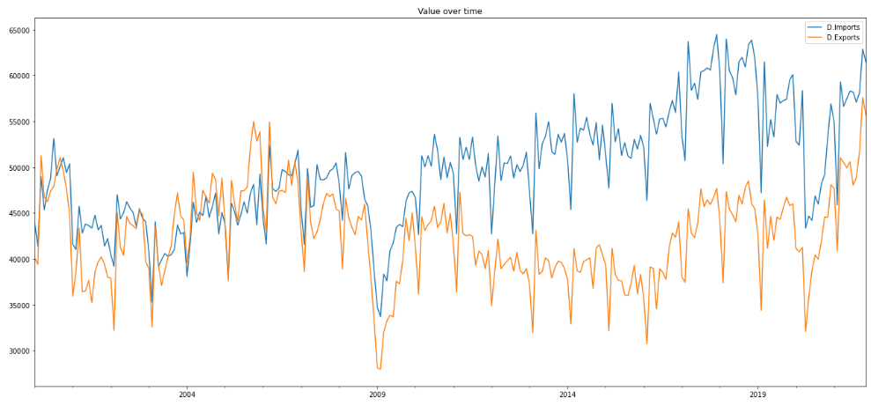

Figure 2 Decompose D-Import and D.Exports into observed, trend, seasonal, residual

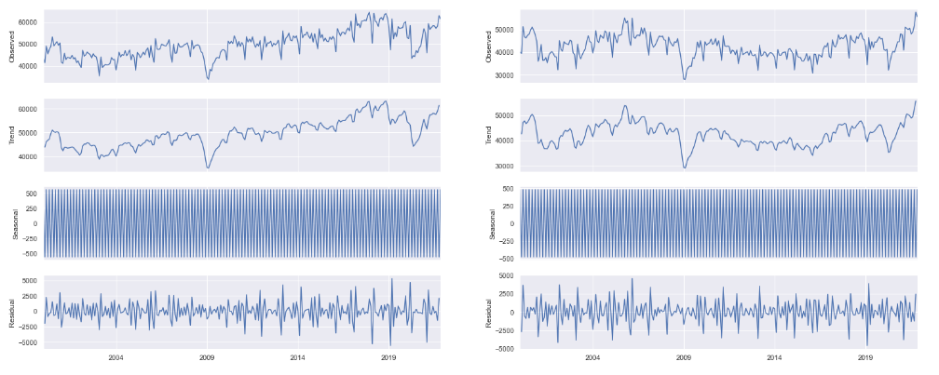

Modelling Process

To infer the trend more precisely, time series autocorrelation (ACF) and partial autocorrelation (PACF) functions were examined. In order to obtain the stationary status of the series, both Detrending and Differencing are used to stationarize the data. After the adjustment, a function in Python which can automatically analyze the time series and produce the most suitable ARIMA and SARIMAX model.

From the models generated in Figure 3, ARIMA(0,1,0) has been chosen as the best model for D.Import and ARIMA(5,1,5) for D.Export respectively. Figure 4 shows that SARIMAX(3,1,3)(3,1,3)12 is best for D.Import and SARIMAX(0,1,0)(3,1,3)12 for D.Export respectively.

Figure 3 The best generated ARIMA model

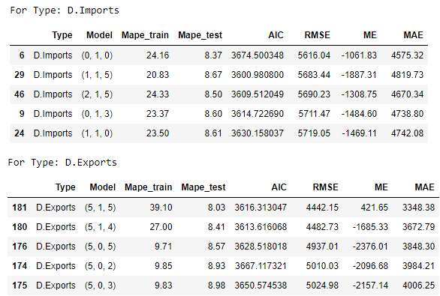

Figure 4 The best generated SARIMAX model

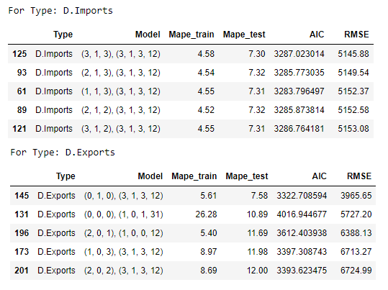

Based on the comparison of evaluation criteria as shown in Table 1, SARIMAX model seems to be better model fitting and forecasting the D.Import and D.Export as compare to ARIMA model. Figure 5 and Figure 6 illustrates the comparison of actual and predicted values when applying the best SARIMAX model for D.Import and D.Export.

Table 1 Compare ARIMA and SARIMAX

|  |  |  |  |  |
| --- | --- | --- | --- | --- |
| Data | Model | MAPE_TRAIN | MAPE_TEST | RMSE |
| D.Import | ARIMA(0,1,0)  SARIMAX(3,1,3)(3,1,3,12) | 24.16  4.58* | 8.37  7.30* | 5616.04  5145.88* |
| D.Export | ARIMA(5,1,5)  SARIMAX(0,1,0)(3,1,3,12) | 39.10  5.61* | 8.03  7.58* | 4442.15  3965.65* |

*indicates better fitting and forecasting

Figure 5 Comparison of Actual and Predicted Values Using SARIMAX(3,1,3)(3,1,3,12) of D.Import

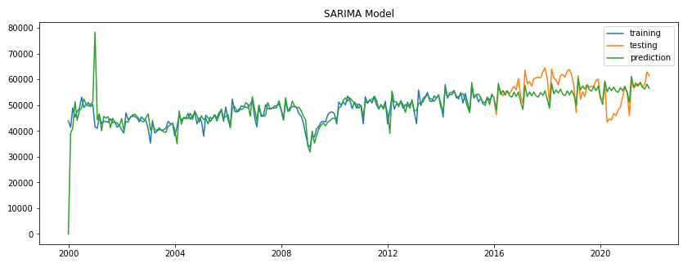

Figure 6 Comparison of Actual and Predicted Values Using SARIMAX(0,1,0)(3,1,3,12) of D.Export

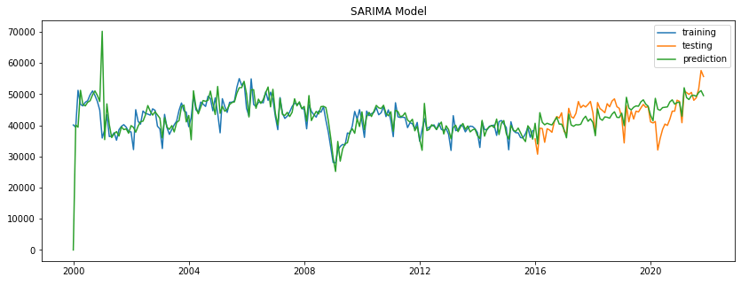

**Forecating Results**

SARIMAX(3,1,3)(3,1,3,12) is utilize to forecast D.Import and SARIMAX(0,1,0)(3,1,3,12) is employed to forecast D.Export. Forecasted values of D.Import show that from the month 2021-12-01 will increase partially and fluctuate slightly (Figure 7). On the other hand, forecasted values of D.Export show that from the month 2021-12-01 will fluctuate slightly with the increasing trends compare to the previous years (Figure 8).

Figure 7 Forecasting Results for D. Import

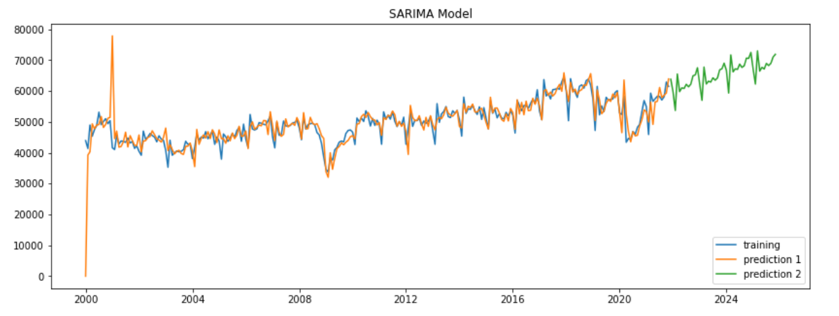

Figure 8 Forecasting Results for D.Export

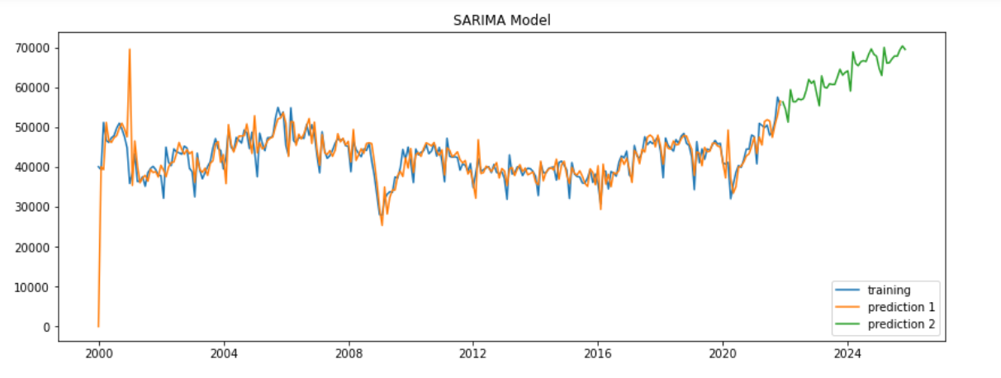

**Conclusion**

In Conclusion, SARIMAX model seems to be better model in fitting and forecasting the D.Import and D.Export as compare to ARIMA model. This study serves as an exploratory to forecast Direct Imports and Direct Exports of Singapore and it is limited to time series model ARIMA and SARIMAX. There is no single best model to do forecasting. Further research using maching learning such as artificial neral network (ANN), prophet, SVR and etc can be carry out to search for more accuracy model in forecasting the Direct Imports and Direct Exports of Singapore.

REFERENCES

[1] <https://tradingeconomics.com/singapore/exports>

[2] <https://tradingeconomics.com/singapore/imports>

[3] Kramer, L. How Importing and Exporting Impacts the Economy, Updated January 30, 2022. Available from https://www.investopedia.com/articles/investing/100813/interesting-facts-about-imports-and-exports.asp#:~:text=A%20country's%20importing%20and%20exporting,on%20a%20country's%20exchange%20rate.

[4] Mehmood, A., Sial, M. H., Sharif, S., Hussain, A., Riaz, M., & Shaheen, N. (2020). Forecasting the Fisheries Production in Pakistan for the Year 2017–2026, using Box-Jenkin's Methodology. Pakistan Journal of Agricultural Research, 33(1). <https://doi.org/10.17582/journal.pjar/2020/33.1.140.145>

[5] Urrutia, J.D, Abdul, A. M and Atienza, J., Forecasting Phillipines Imports and Exports using Bayesian artificial neural network and autoregressive integrated moving average, AIP Conference Proceedings 2192, 090012 (2019). Available from chrome-extension://efaidnbmnnnibpcajpcglclefindmkaj/https://aip.scitation.org/doi/pdf/10.1063/1.5139185

[6] Ghauri, S.P., Ahmed, R.R., Streimikiene, D., and Streimikis, J., Forecasting Exports and Imports by using Autoregressive (AR) with Seasonal Dummies and Box-Jenkins Approaches: A Case of Pakistan. 2020. Available from http://dx.doi.org/10.5755/j01.ee.31.3.25323

[7] Bartholomew DJ, Box GEP, Jenkins GM. Time Series Analysis Forecasting and Control. Operat Res Quarter. 1971;22(2):199

[8] Filippo, <M.D>. Time Series Forecast in Python using SARIMAX and PROPHET, 2021. Available from <https://towardsdatascience.com/time-series-forecast-in-python-using-sarimax-and-prophet-c970e6056b5b>

[9] Shao, V., Forecasting with a Time Series Model using Python: Part One. 2020. Available from <https://www.bounteous.com/insights/2020/09/15/forecasting-time-series-model-using-python-part-one/>

[10] <https://www.singstat.gov.sg/find-data/multi-dimensional-data-cubes>